SIMATS ENGINEERING
ASSESSMENT TOOL 1

COURSE NAME: Database Management Systems
COURSE CODE: CSA0501

COURSE OUTCOME COVERED

CO1: Analyze DBMS architecture, different data models, schema types, and design ER/EER diagrams, relational schemas for case-based scenarios by identifying entities and relationships. (BL1, BL2)

Activity Tool : Short Answer Text(High)
Assessment Tool Weightage: 30%

Dr

QUESTIONS Total Marks: 50
Q.No | Question | Bloom's Level | Marks
1 | UPS Product Tracking Information System  UPS prides itself on having up-to-date information on the processing and current location of each shipped item. To do this, UPS relies on a company-wide information system. Shipped items are the heart of the UPS product tracking information system. Shipped items can be characterized by item number (unique), weight, dimensions, insurance amount, destination, and final delivery date. Shipped items are received into the UPS system at a single retail center. Retail centers are characterized by their type, uniqueID, and address. Shipped items make their way to their destination via one or more standard UPS transportation events (i.e., flights, truck deliveries). These transportation events are characterized by a unique scheduleNumber, a type (e.g, flight, truck), and a deliveryRoute. Create an Entity Relationship diagram that captures this information about the UPS system. | BL1 – Remember | 5
2 | Course Management System  Consider a university database for the scheduling of classrooms for final exams. This database could be modeled as the single entity set exam, with attributes course-name, section-number, room-number, and time. Alternatively, one or more additional entity sets could be defined, along with relationship sets to replace some of the attributes of the exam entity set, as  • course with attributes name, department, and c-number  • section with attributes s-number and enrollment, and dependent as a weak entity set on course  • room with attributes r-number, capacity, and building  Show an E-R diagram illustrating the use of all three additional entity sets listed. | BL2 – Understand | 5
3 | University Registrar’s Office Management System  A university registrar’s office maintains data about the following entities:  - courses, including number, title, credits, syllabus, and prerequisites;  - course offerings, including course number, year, semester, section number, instructor(s), timings, and classroom;  - students, including student-id, name, and program;  - instructors, including identification number, name, department, and title.  - Further, the enrollment of students in courses and grades awarded to students in each course they are enrolled for must be appropriately modeled.  Construct an E-R diagram for the registrar’s office. | BL2 – Understand | 5
4 | Hospital Management System  Construct an E-R diagram for a hospital with a set of patients and a set of medical doctors.  Associate with each patient a log of the various tests and examinations conducted. Construct appropriate tables for the above ER Diagram :  Patient(SS#, name, insurance)  Physician ( name, specialization)  Test-log( SS#, test-name, date, time)  Doctor-patient (physician-name, SS#)  Patient-history(SS#, test-name, date) | BL2 – Understand | 5
5 | Company Project Management System  Construct an ER Diagram for Company having following details :  Company organized into DEPARTMENT. Each department has unique name and a particular employee who manages the department. Start date for the manager is recorded. Department may have several locations.  • A department controls a number of PROJECT. Projects have a unique name, number and a single location.  • Company’s EMPLOYEE name, ssno, address, salary, sex and birth date are recorded. An employee is assigned to one department, but may work for several projects (not necessarily controlled by dept). Number of hours/week an employee works on each project is recorded; The immediate supervisor for the employee.  • Employee’s DEPENDENT are tracked for health insurance purposes (dependentname, birthdate, relationship to employee). | BL2 – Understand | 5
6 | Explain schema and instance with examples. Distinguish between logical schema, physical schema, and view schema. | BL1 – Remember | 5
7 | Identify the entities, attributes, and relationships for a Bank Management System and construct its ER diagram. | BL2 – Understand | 5
8 | Explain the Extended ER (EER) model. Describe the concepts of generalization, specialization, and aggregation. | BL2 – Understand | 5
9 | Design an EER diagram for a Hospital Management System incorporating inheritance and weak entities. | BL2 – Understand | 5
10 | Explain the role of a DBA (Database Administrator) and the responsibilities associated with the position. | BL1 – Remember | 5

Code of Conduct:

I K SARANYA (192424409) (Name / Reg No) certify that this submission is my original work and that I have adhered to the guidelines specified for this assessment.
I understand that any violation of academic integrity rules will result in disciplinary action.

Signature of the student:
K.Saranya

RUBRICS FOR CALCULATION:

Criteria | Weightage | Level 4 (Exemplary) | Level 3 (Proficient) | Level 2 (Developing) | Level 1 (Beginning)
Concept Identification | 30% | Demonstrates  clear and  complete  understanding of  the concept | Good  understanding  with minor  gaps | Basic  understanding  with some  misconceptions | Poor or  incorrect  understandin  g
Linkages | 25% | Completely  correct answer  with no errors | Mostly correct  with minor  errors | Partially correct  with noticeable  errors | Incorrect or  irrelevant  answer
Organization | 20% | Correctly applies  concepts to solve  the  question/problem | Applies  concepts with  minor  mistakes | Limited or  partially correct  application | No or  incorrect  application
Integration of Literature | 15% | Covers all  required parts of  the question | Covers most  parts with  minor  omissions | Covers only  some parts | Incomplete  or missing  response
Clarity | 10% | Clear, concise,  and well-  organized answer | Understandabl  e with minor  issues | Somewhat  unclear or poorly  structured | Difficult to  understand

Q1. UPS Product Tracking Information System
- SHIPPED_ITEM (itemNumber [PK], weight, dimensions, insuranceAmount, destination, finalDeliveryDate)
- RETAIL_CENTER (uniqueID [PK], type, address)
- TRANSPORT_EVENT (scheduleNumber [PK], type, deliveryRoute)
Relationships:
- RECEIVED_AT: RETAIL_CENTER (1) -- SHIPPED_ITEM (N) — each item is received at exactly one retail center.
- ROUTED_VIA: SHIPPED_ITEM (N) -- TRANSPORT_EVENT (M) — an item may travel through several transport events, and an event carries many items.

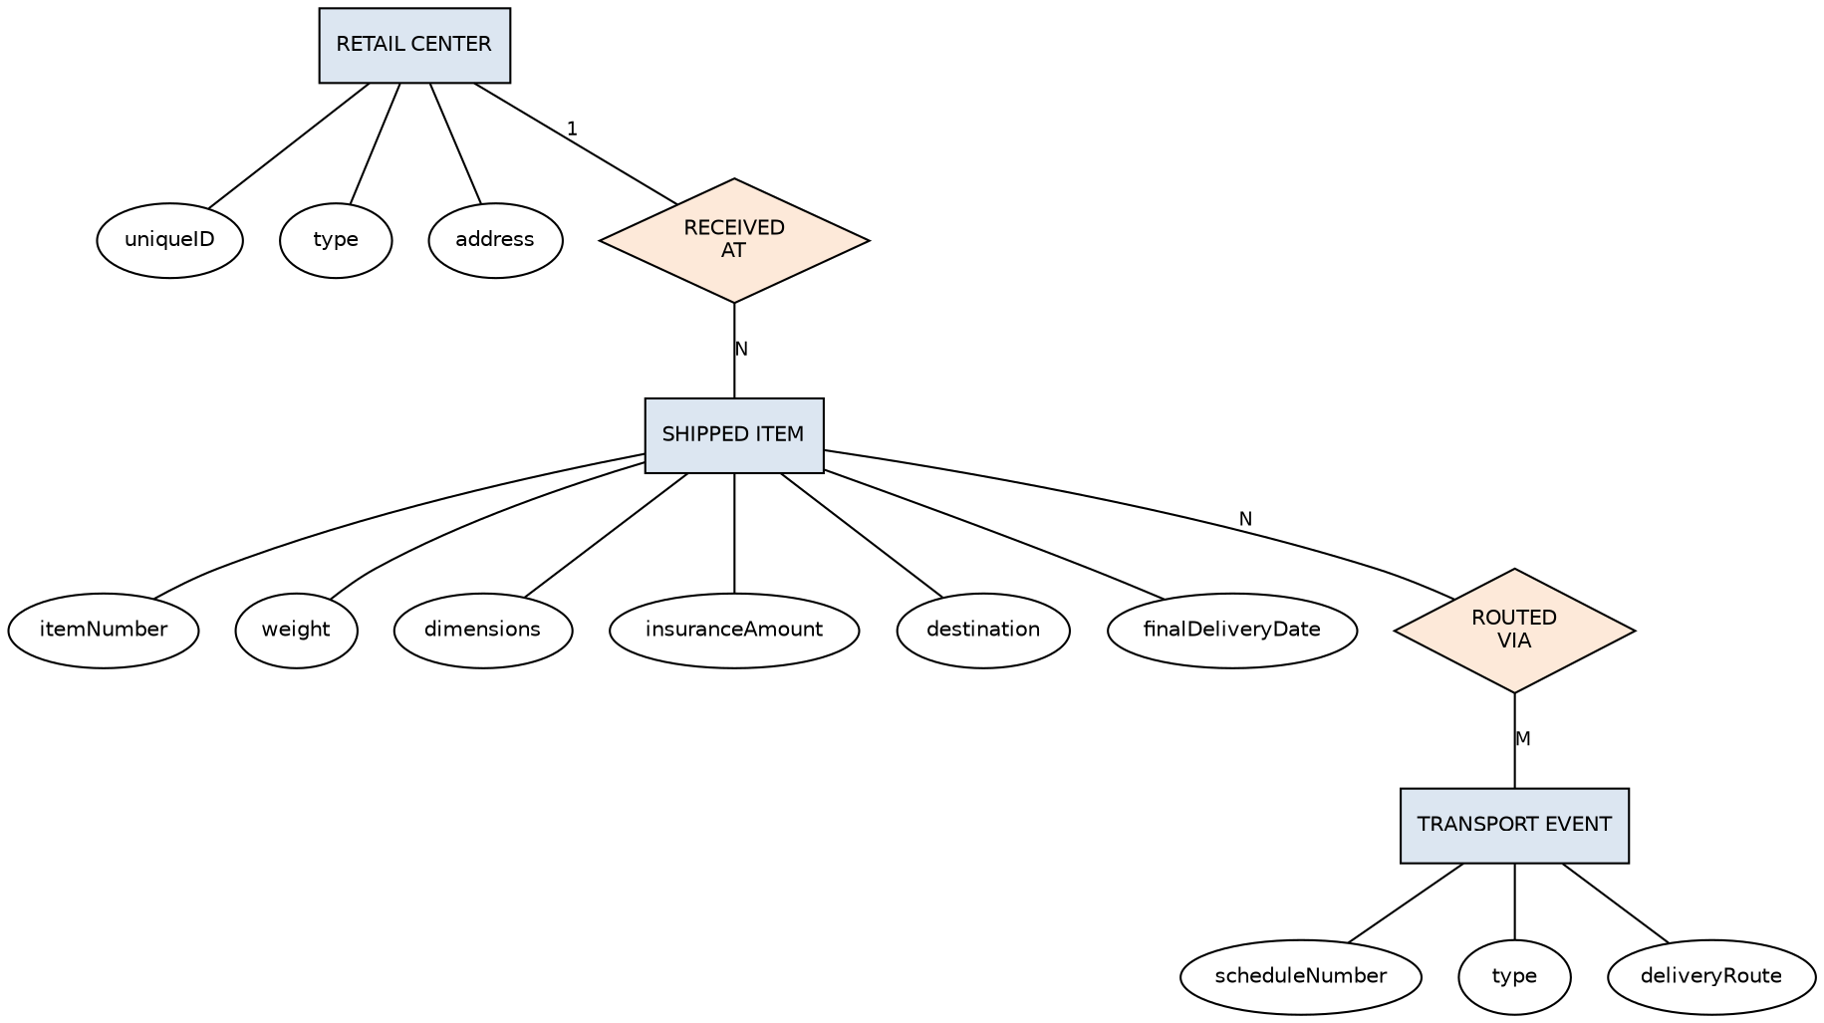

Q2. Course Management System
- COURSE (name, department, c-number)
- SECTION (s-number, enrollment) — weak entity, identifying owner: COURSE
- ROOM (r-number, capacity, building)
Relationships:
- HAS (identifying): COURSE (1) -- SECTION (N)
- SCHEDULED_IN: SECTION (N) -- ROOM (M), with descriptive attribute 'time'

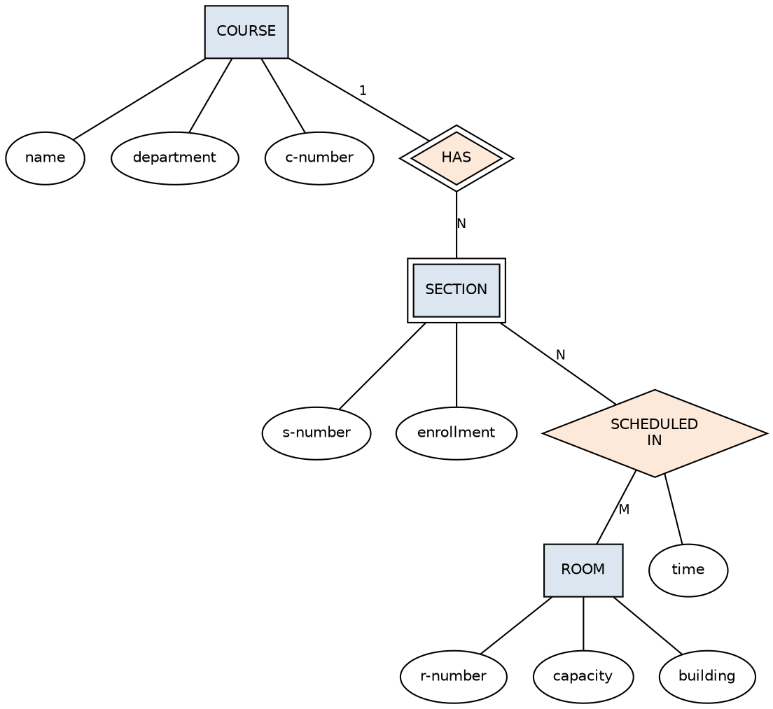

Q3. University Registrar's Office Management System
- COURSE (number [PK], title, credits, syllabus, prerequisites)
- COURSE_OFFERING (year, semester, section-number, timings, classroom) — weak entity owned by COURSE
- STUDENT (student-id [PK], name, program)
- INSTRUCTOR (id-number [PK], name, department, title)
Relationships:
- OFFERS (identifying): COURSE (1) -- COURSE_OFFERING (N)
- TEACHES: INSTRUCTOR (M) -- COURSE_OFFERING (N) — supports multiple instructors per offering
- ENROLLS: STUDENT (M) -- COURSE_OFFERING (N), with descriptive attribute 'grade'
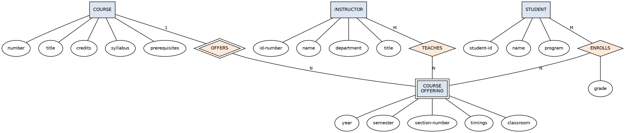

Q4. Hospital Management System
- PATIENT (SS# [PK], name, insurance)
- PHYSICIAN (name, specialization)
- TEST_LOG (test-name, date, time) — weak entity owned by PATIENT
Relationships:
- DOCTOR_PATIENT: PHYSICIAN (M) -- PATIENT (N)
- PATIENT_HISTORY (identifying): PATIENT (1) -- TEST_LOG (N)

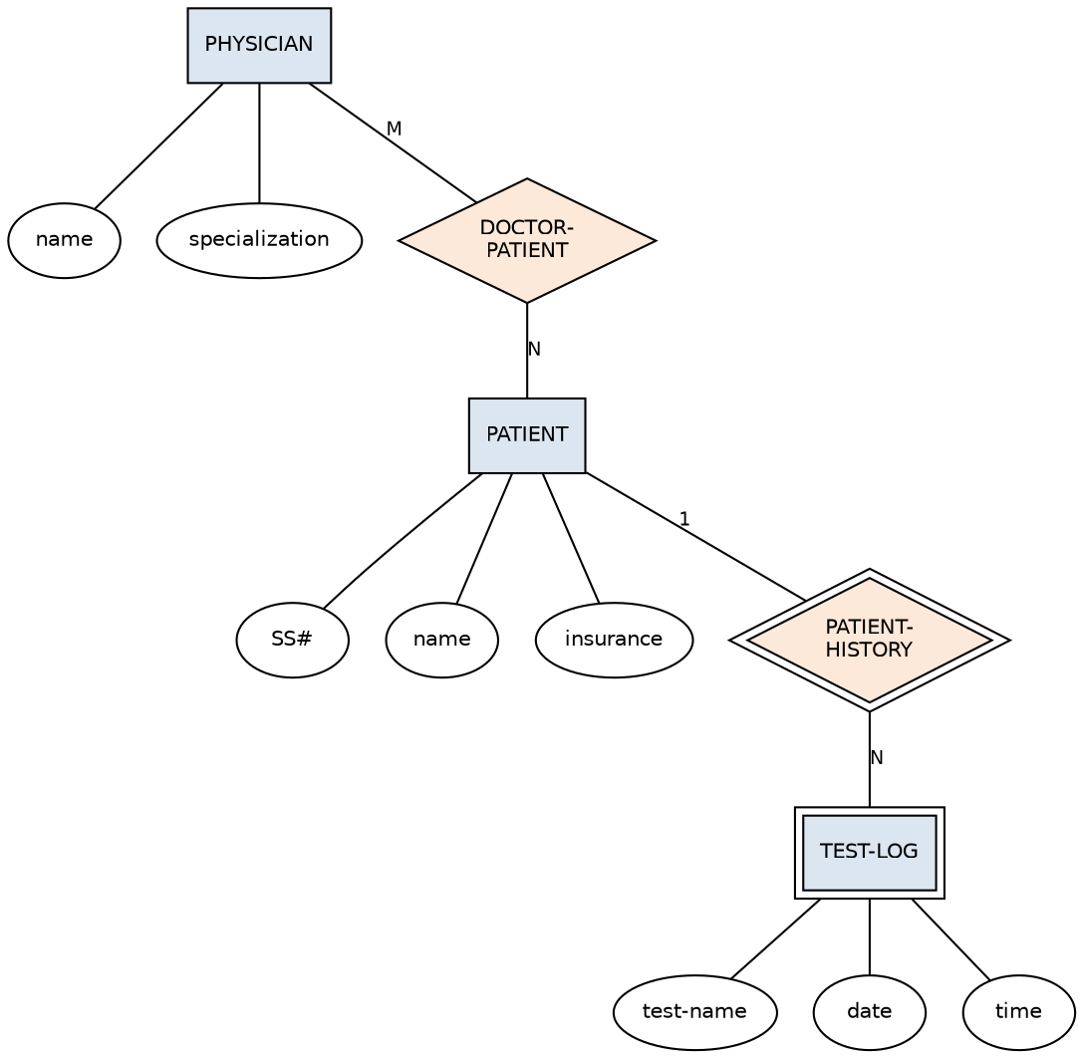

Q5. Company Project Management System
- DEPARTMENT (Dname [PK], {Dlocations})
- EMPLOYEE (Name, SSN [PK], Address, Salary, Sex, Bdate)
- PROJECT (Pname [PK], Pnumber, Plocation)
- DEPENDENT (Dependent_name, Birthdate, Relationship) — weak entity owned by EMPLOYEE
Relationships:
- MANAGES: DEPARTMENT (1) -- EMPLOYEE (1), with attribute Start_date
- WORKS_FOR: EMPLOYEE (N) -- DEPARTMENT (1)
- CONTROLS: DEPARTMENT (1) -- PROJECT (N)
- WORKS_ON: EMPLOYEE (M) -- PROJECT (N), with attribute Hours
- SUPERVISION: EMPLOYEE (1) -- EMPLOYEE (N), recursive relationship for immediate supervisor
- DEPENDENTS_OF (identifying): EMPLOYEE (1) -- DEPENDENT (N)
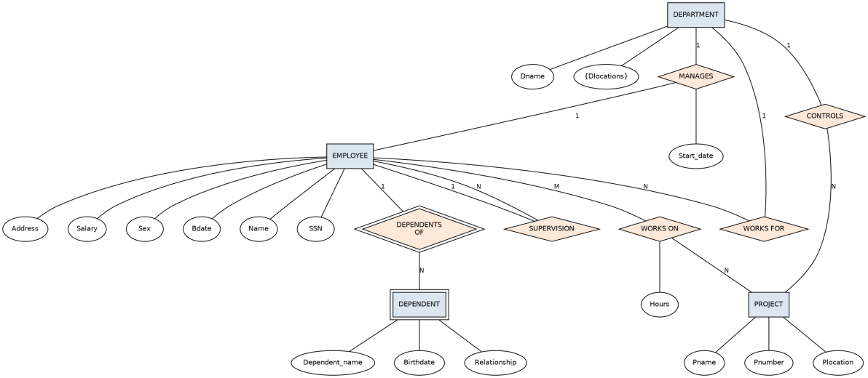

Q6. Schema, Instance, and Levels of Abstraction
A schema is the overall design/structure of a database — the set of entities, attributes, relationships, and constraints defined at design time. It rarely changes.
An instance is the actual data stored in the database at a particular moment in time. It changes frequently as data is inserted, updated, or deleted.
Example: In a STUDENT(roll_no, name, dept) schema, the schema itself stays fixed, but an instance might be {(101, 'Aman', 'CSE'), (102, 'Riya', 'ECE')} today and a different set of rows tomorrow.
- Physical schema: describes how data is actually stored on disk — file organization, indexes, storage structures.
- Logical schema (conceptual schema): describes the overall database structure — entities, attributes, relationships, constraints — independent of physical storage. This is what DB designers work with.
- View schema (external schema): describes a specific user's or application's partial view of the database, hiding irrelevant parts for security/simplicity.
These three levels give data independence: changes at one level (e.g., physical storage) need not affect the levels above it (logical, view).

Q7. Bank Management System
- BRANCH (branch-name [PK], branch-city, assets)
- CUSTOMER (customer-id [PK], name, address)
- ACCOUNT (account-number [PK], balance, type)
- LOAN (loan-number [PK], amount)
- EMPLOYEE (employee-id [PK], name, title)
Relationships:
- HAS: BRANCH (1) -- ACCOUNT (N)
- HAS: BRANCH (1) -- LOAN (N)
- DEPOSITOR: CUSTOMER (M) -- ACCOUNT (N)
- BORROWER: CUSTOMER (M) -- LOAN (N)
- WORKS_AT: EMPLOYEE (N) -- BRANCH (1)
- CUST_BANKER: CUSTOMER (N) -- EMPLOYEE (1)
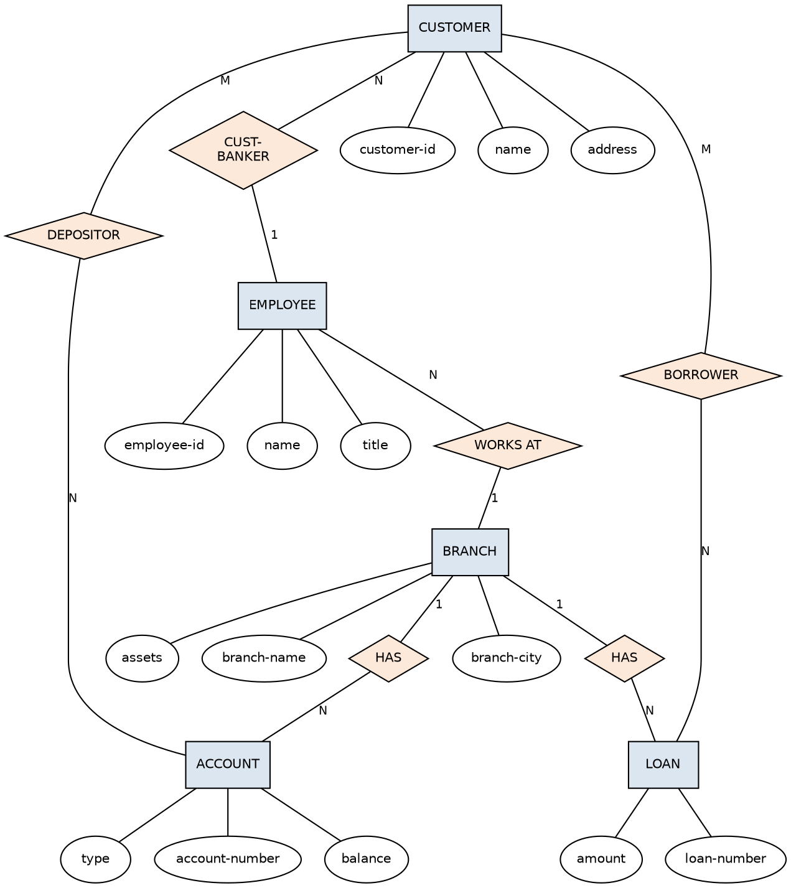

Q8. Extended ER (EER) Model
Generalization is a bottom-up process where two or more lower-level entity sets with common attributes are combined to form a single higher-level (generalized) entity set. Example: EMPLOYEE and STUDENT can be generalized into PERSON.
Specialization is a top-down process where a higher-level entity set is divided into lower-level entity sets based on distinguishing characteristics. Example: EMPLOYEE can be specialized into SECRETARY, ENGINEER, and MANAGER.
Specializations can be disjoint (an entity belongs to only one subclass, shown as 'D') or overlapping (an entity may belong to more than one subclass, shown as 'O'). They can also be total (every higher-level entity must belong to a subclass) or partial.
Aggregation is an abstraction in which a relationship set (along with its participating entity sets) is treated as a higher-level entity set, allowing it to participate in further relationships. It is used when a relationship itself needs to be related to another entity.
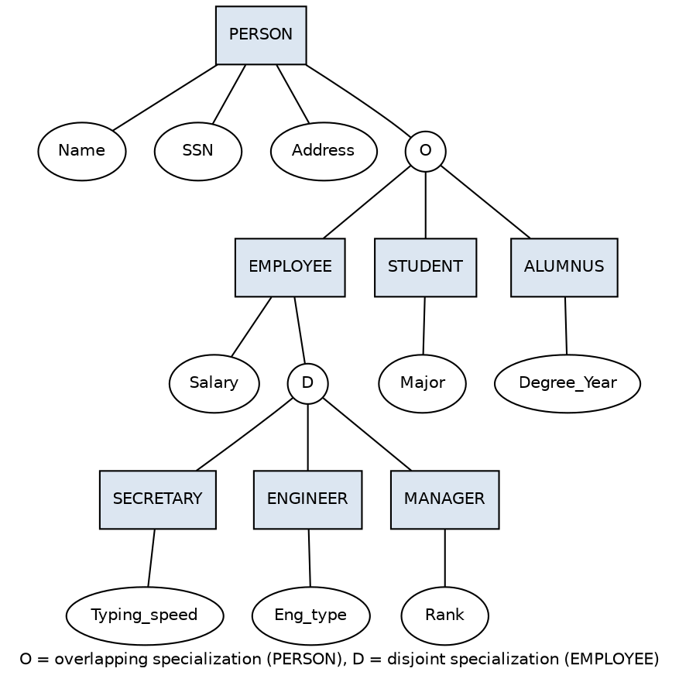

Q9. Hospital Management System - EER Diagram
PERSON is generalized into two disjoint subclasses: PATIENT and STAFF, since every person in the system is either a patient or a staff member (or both, if modeled as overlapping).
- PATIENT specializes further (disjoint) into INPATIENT (admitted, has Room_no) and OUTPATIENT (visits only, has Visit_date).
- STAFF specializes further (disjoint) into DOCTOR, NURSE, and TECHNICIAN, each with role-specific attributes.
- TEST_RESULT is a weak entity, existence-dependent on PATIENT through the identifying relationship UNDERGOES.
- TREATS is a relationship between DOCTOR and PATIENT (M:N).
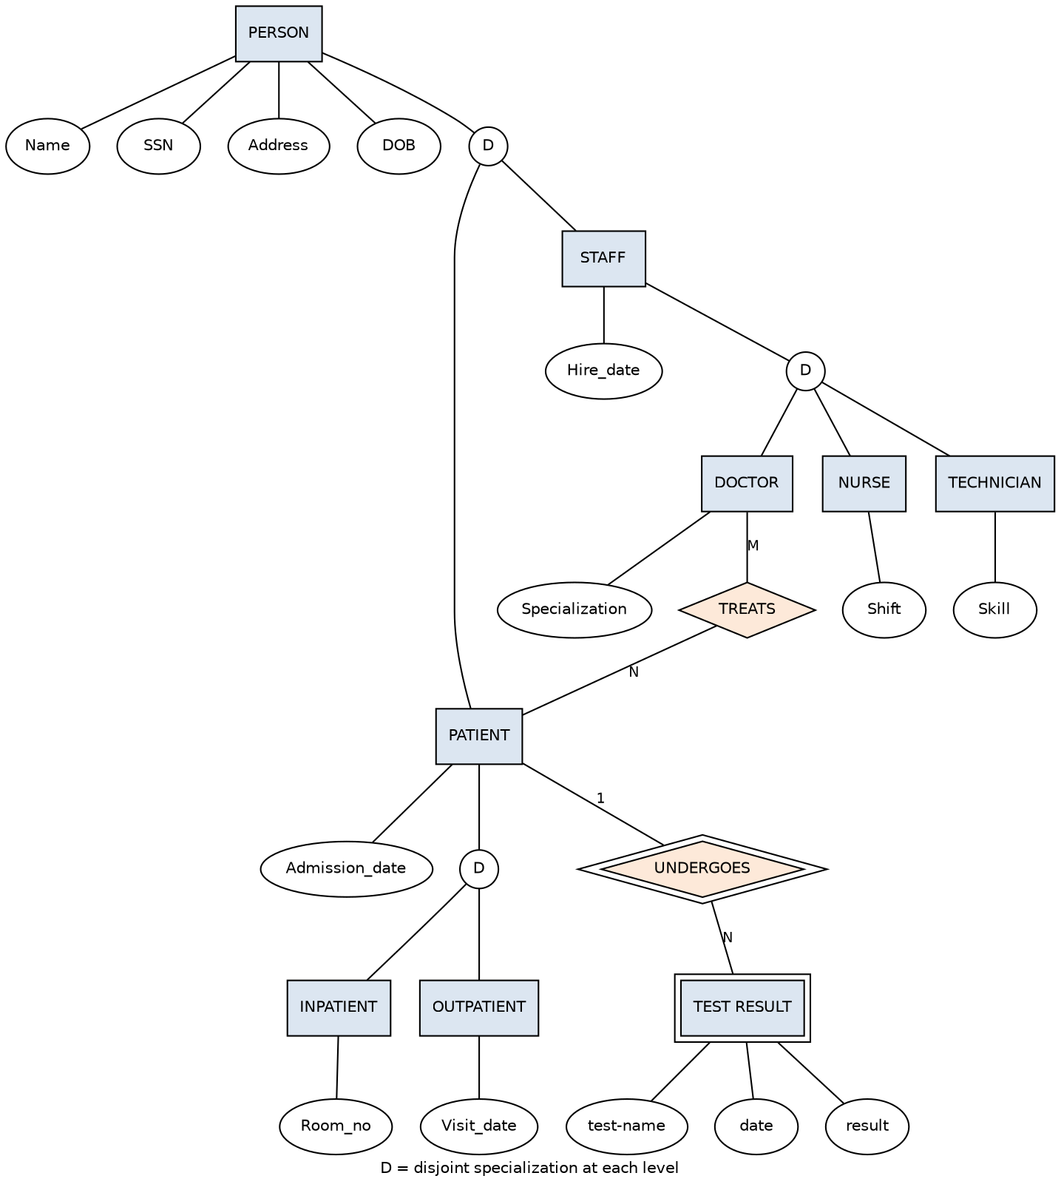

Q10. Role of a Database Administrator (DBA)
The DBA is the person (or team) responsible for the overall control, coordination, and management of the database system, ensuring it is secure, available, and performs well for all its users.
- Schema definition: creating and modifying the database schema.
- Storage structure and access method definition: choosing appropriate physical storage and indexing strategies.
- Granting authorization for data access: managing user privileges and roles.
- Routine maintenance: taking backups, monitoring disk usage, ensuring adequate storage.
- Ensuring data security and integrity: enforcing constraints and access controls.
- Performance monitoring and tuning: optimizing queries and system configuration.
- Recovery planning: setting up procedures to recover from hardware/software failures.
- Liaising with users: coordinating with application developers and end users on database requirements.

